# 

# 1.INTRODUCTION

# 1.1 Overview

**A visa slot management project is a system that is used to track and manage the**

**Availability of visa slots, which are appointments that are required for certain visa**

**Applications. It might be used by a government agency or a visa processing centre to**

**Schedule and manage appointments with applicants.**

# 1.2 Purpose

* **To track and manage the availability of visa slots.**

**Visa Consultant-Apply for Visa processing.**

# 2.PROBLEM DEFINITION & DESIGN THINKING

# 2.1 Empathy map

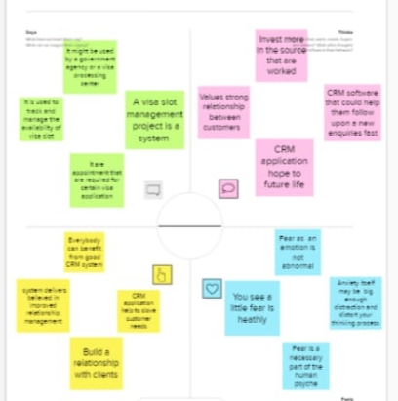

# 2.2 Ideation & Brainstroming map

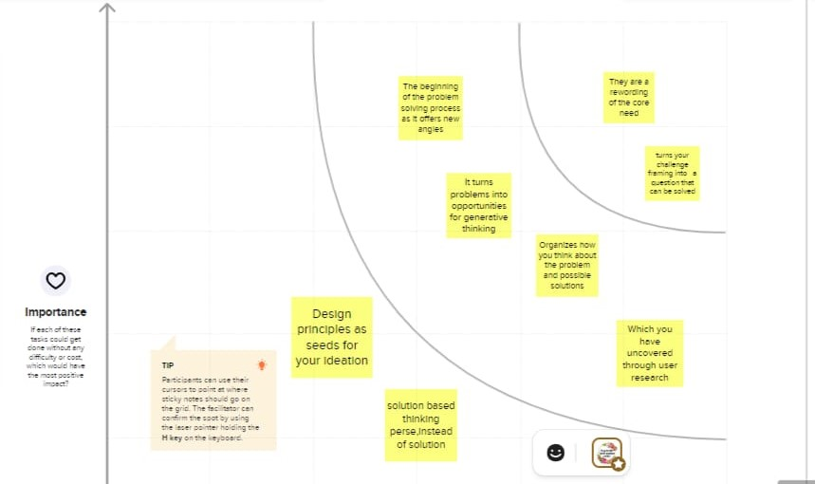

# 3.RESULT

|  |  |
| --- | --- |
| OBEJECT NAME | FIELDS IN THE OBJECT |
| OBJ1 | |  |  | | --- | --- | | Field label  Ff | Data type | | Apply for visa | Text | | Visa slots | Text | |
| OBJ2 | |  |  |  | | --- | --- | --- | | Field label | Data type |  | | shedule | Auto Number | | Manage appointments | Text | |

# 3.2 Activity & Screenshot

# Milestone-1:Creation of developer org

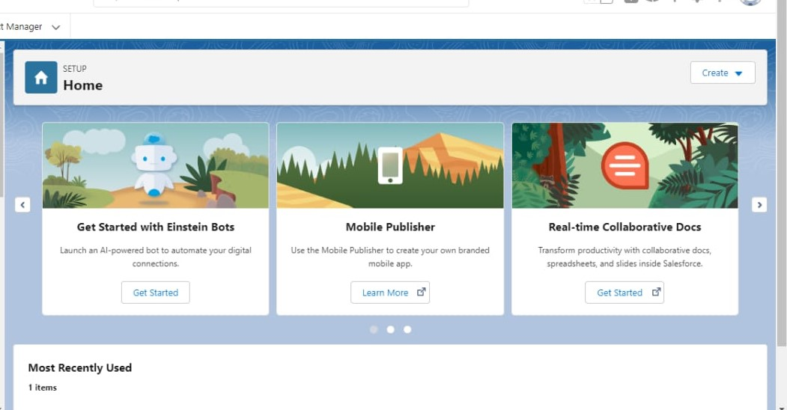

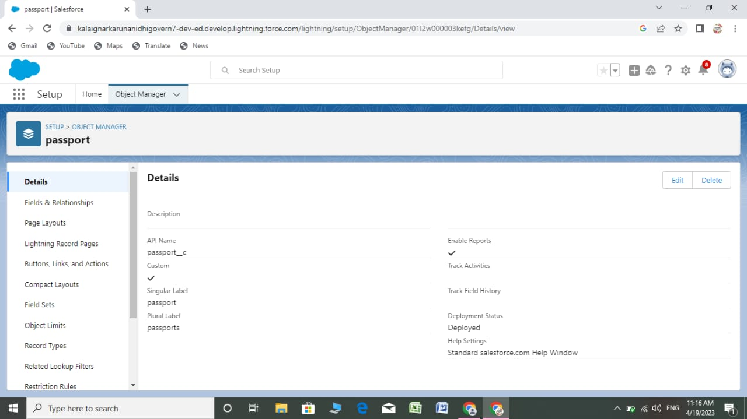

# Milestone-2Objects:

# Activity-1

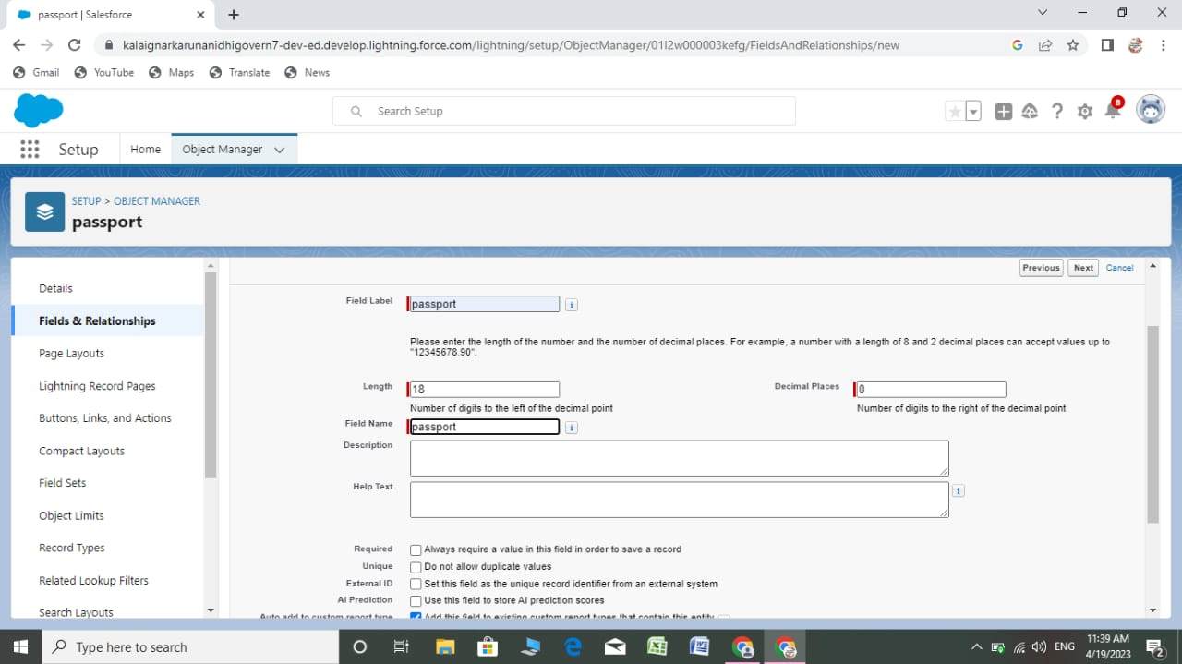

# Milestone-3:Relationship B/w Objects

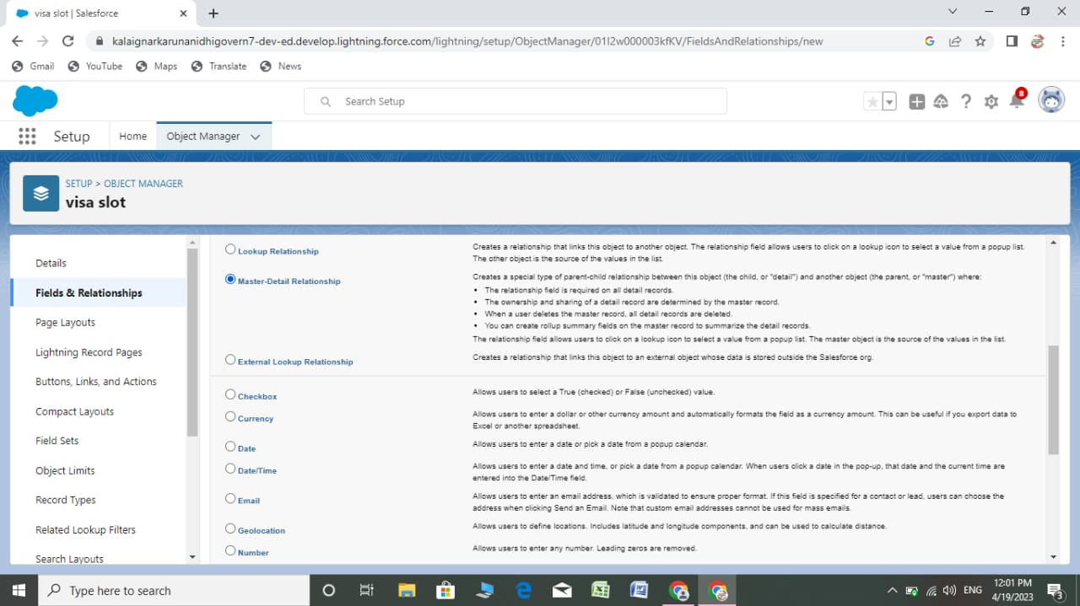

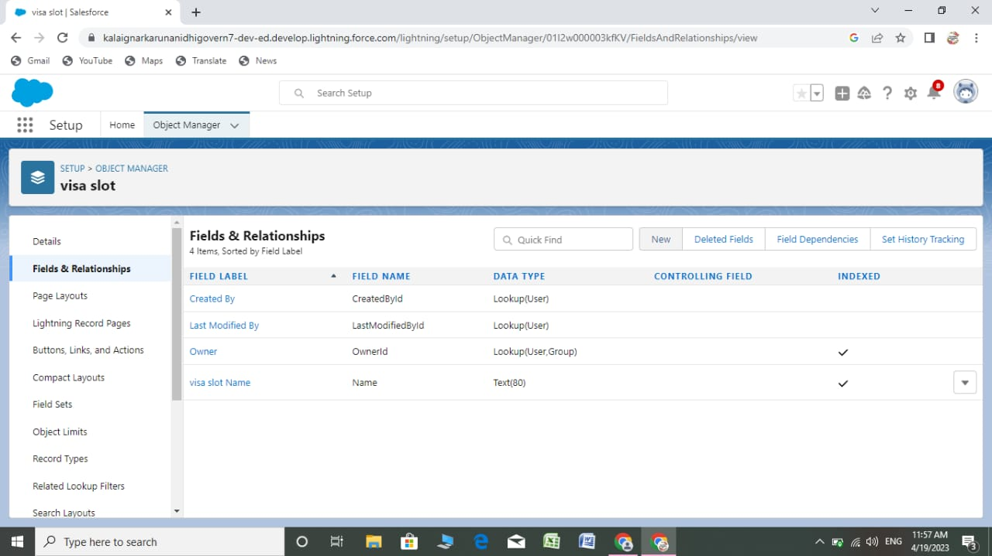

# WhatsApp Image 2023-04-22 at 14.46.04.jpeg

# Milestone-4 App:

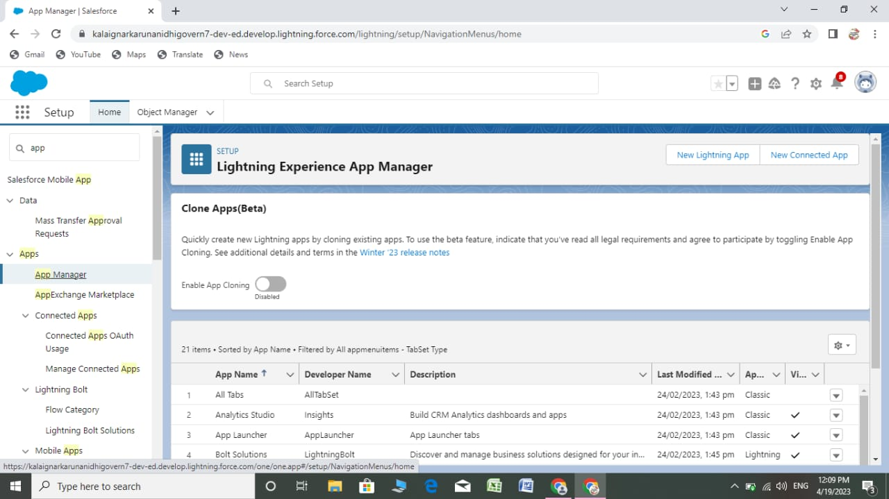

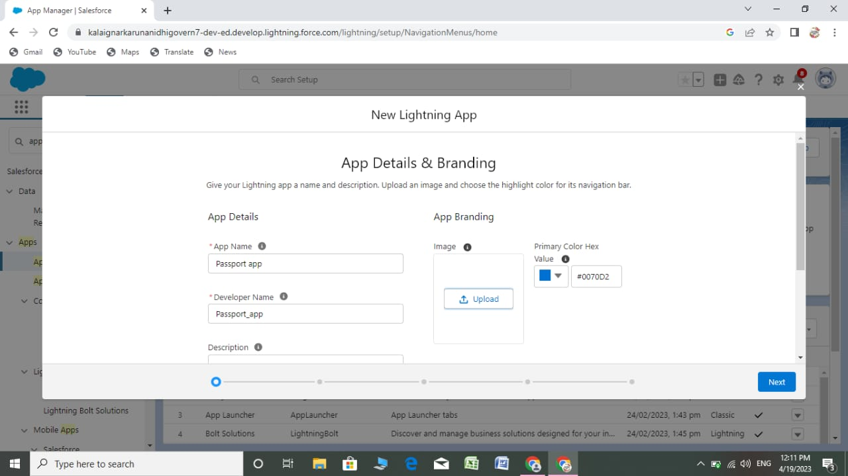

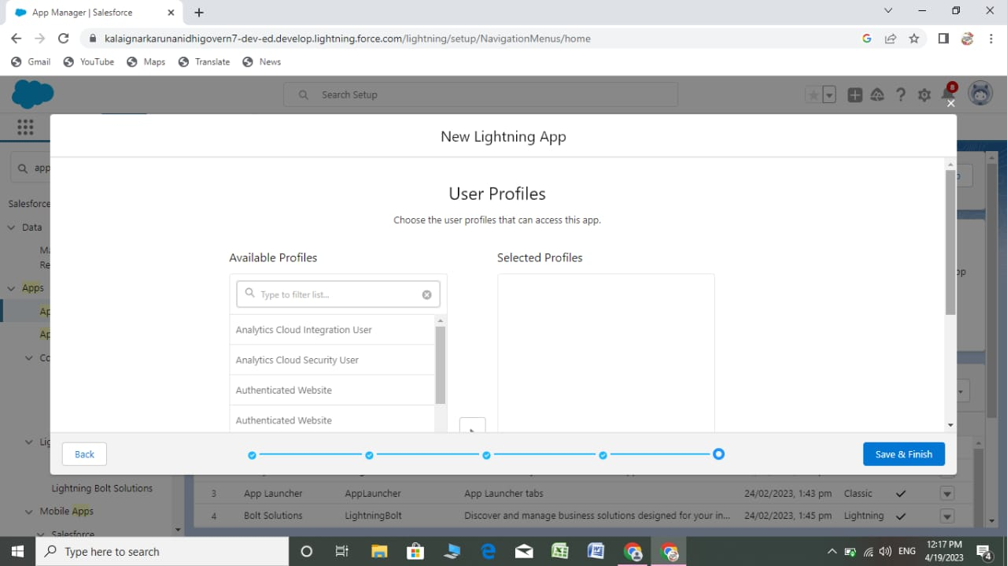

## Milestone-5:User:

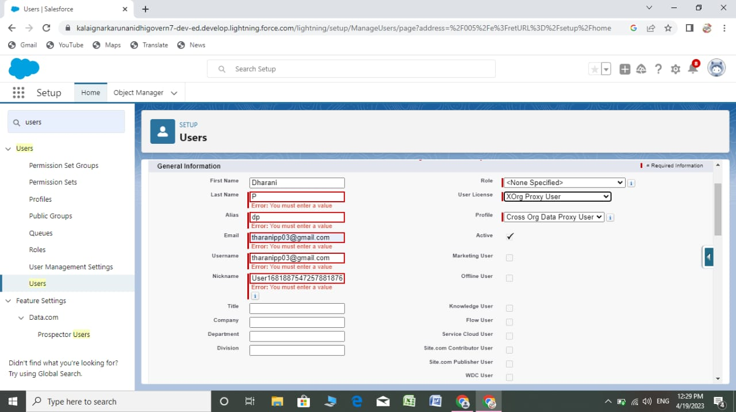

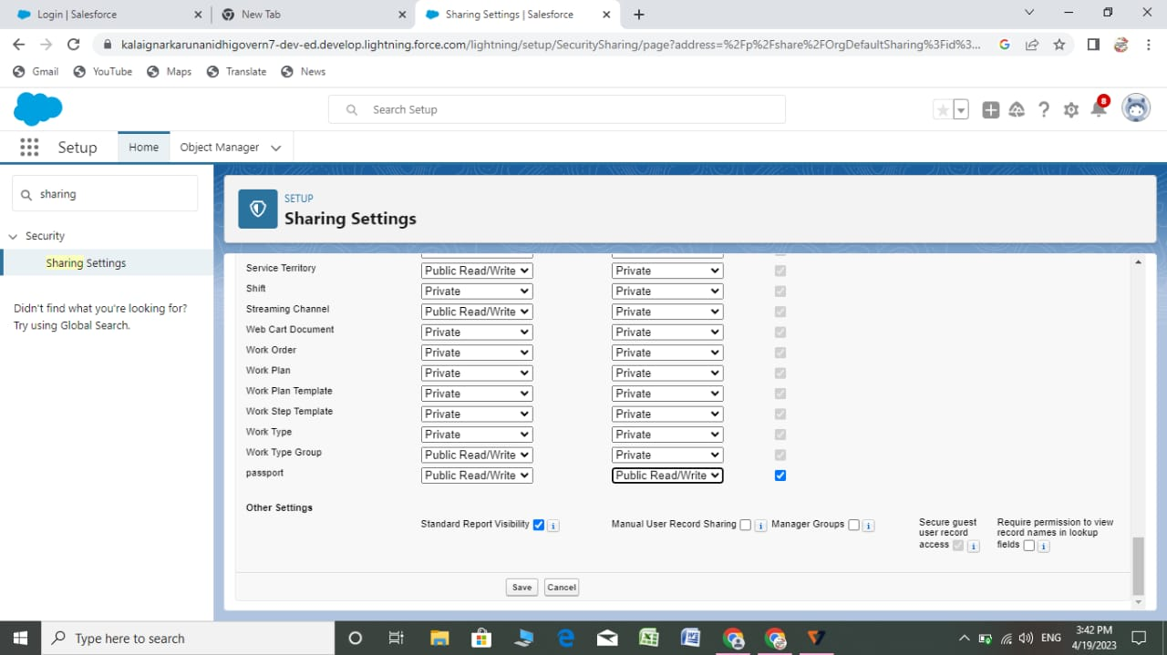

# Milestone-6 Reports:

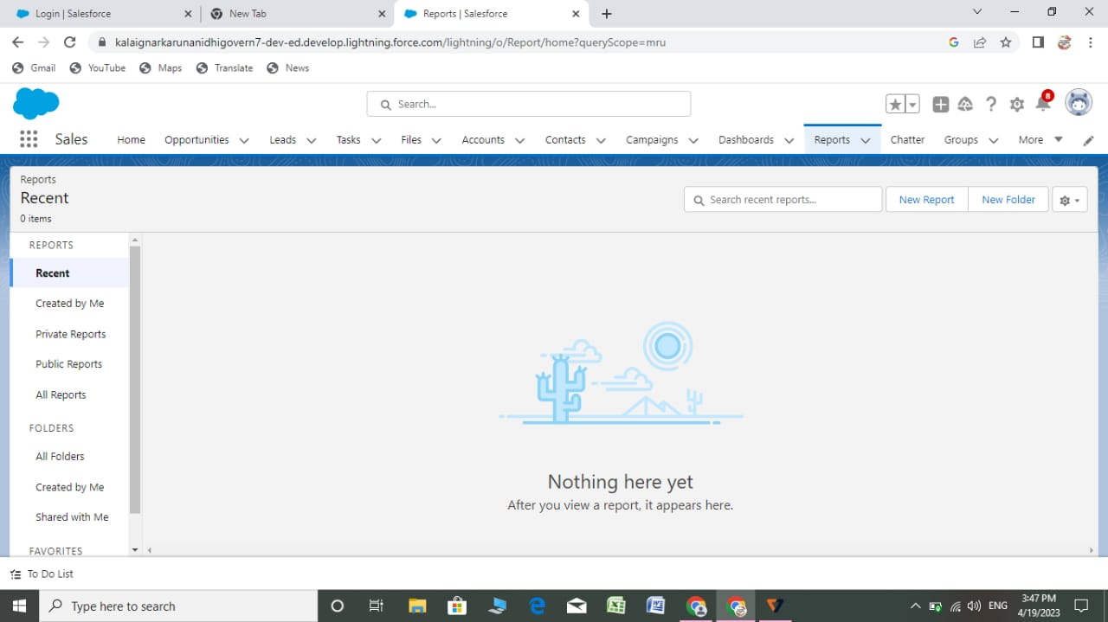

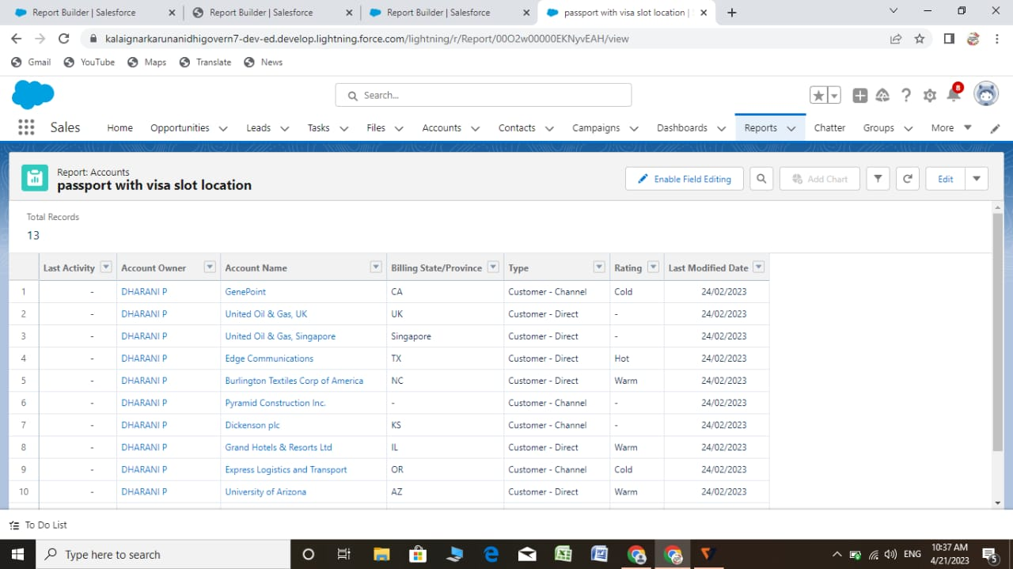



# Milestone-7 Dashboard



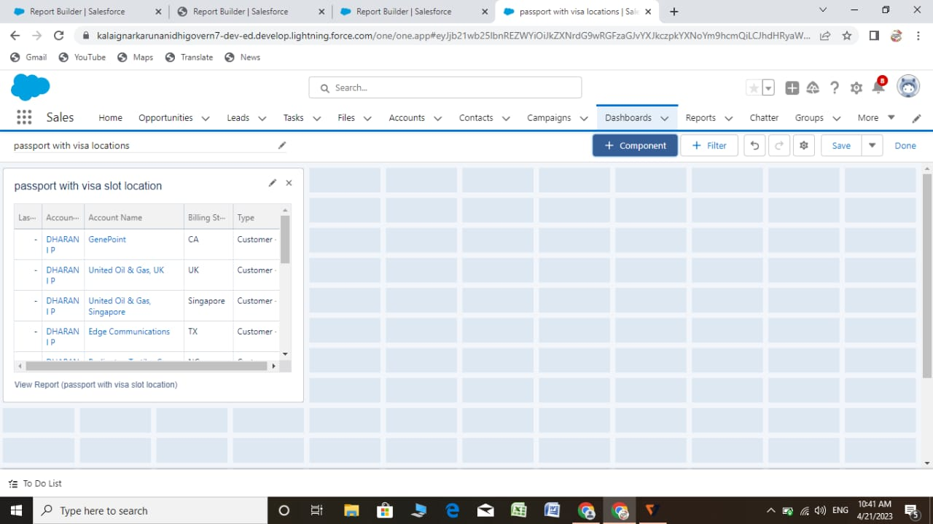

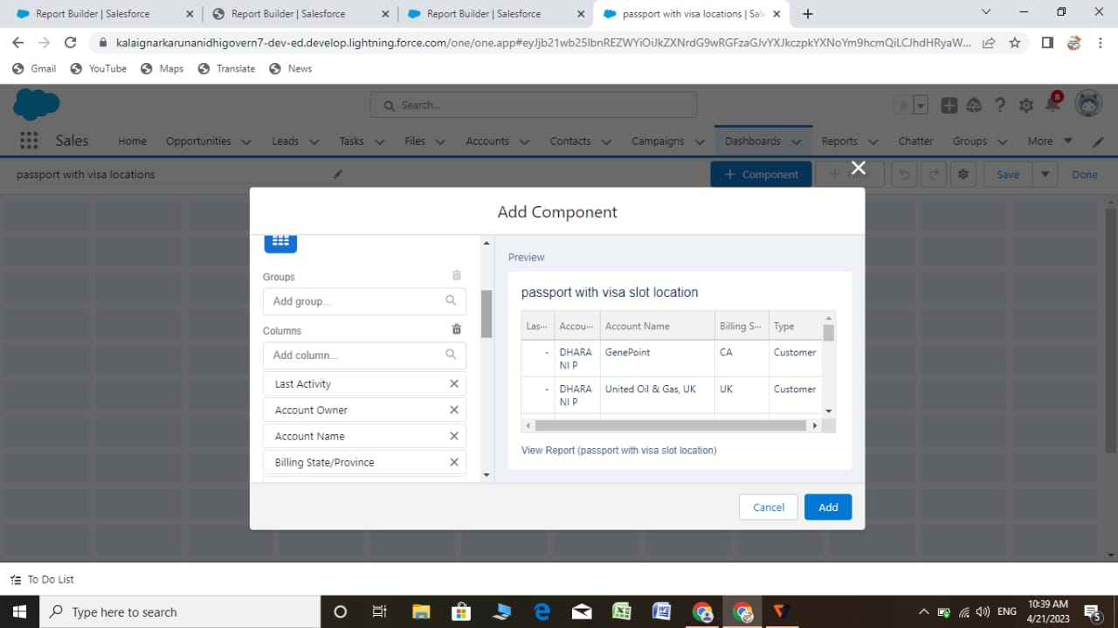

# 4. TRAILHEAD PROFILE PUBLIC URL

**Team Lead-** <https://trailblazer.me/id/jobra074>

**Team Member 1-** <https://trailblazer.me/id/gnanb4>

**Team Member 2-** <https://trailblazer.me/id/dpp03>

**Team Member 3-**  <https://trailblazer.me/id/divys44>

# 5.ADVANTAGES & DISADVANTAGE

* **Great information visibility helps manager plan, excute and evaluate results with**

**Precision and speed.**

* **Better communicationskills, formulate more accurate predictions.**

# DISADVANTAGES

* **Information overloaded, companiens have acces to more information than they**

**Accustomed to managing.**

# 6.APPLICATIONS

**You can create and manage solutions records within a service desk environment.**

**A Solution is a predefined response to a problem or a lesson from an after**

**Action review. The solution record defines a symptob a causes and a resolution.**

**Solution administrators can create solution records in the solutions applications.**

**Users can create draft solution by using the CREATION SOLUTION action in the**

**Ticket Applications .**

# 7.CONCLUSION

**Turism and booking companiens are part of the turism sector and need the**

**CRM system to regulate their relationship with tourists and travelers through CRM**

**Through CRM will be able to track the wishes of their prospective customers**

**Target potential problems of their current customers and workers.**

# 

# 8.FUTURE SCOPE

**Companiens will be able to pivot to meet the changing needs and trends –**

**Driven by custermers expectations.**